Formal Methods for LLM Prompt Engineering
Uyen Nguyen, Justin Cheung, Steven Wacker, Kellen Riley (Johns Hopkins University)

Abstract:
Large language models (LLMs) have demonstrated a widely recognized ability to answer questions and solve problems phrased in natural language, generalizing beyond the observations they were trained on. Natural language prompts can be provided to interfaces such as ChatGPT or the OpenAI API to allow LLMs to produce natural language responses, making this general problem-solving capability highly accessible to apply to new domains. However, these responses are known to lack reliability, or the assurance that outputs are factually correct or consistent [1]. We will discuss strategies and applications for formal methods to improve LLM reliability through prompt engineering.

Introduction

Background and Motivation
Language modeling has been a key area of research for creating artificial intelligence which can interface with, capture patterns in, and solve problems involving natural language. Over time, language modeling has evolved from statistical language models based on the Markov assumption applied to small context windows, to small neural networks which learn vector representations of words, to pretrained language models whose learned features could be fine-tuned to new downstream tasks, to modern large language models whose increased capacity allows unprecedented generalization even to tasks they were not explicitly trained on, as we see with LLMs like GPT which have been adapted for use cases such as interactive conversation [2]. With this new conversational capacity in particular, the field of prompt engineering has arisen to enhance the quality of LLM outputs through careful formulation of their input prompts, making the most of pretrained model parameters without requiring expensive retraining [3].
Although LLMs have significant capability to help solve problems phrased in human language, there is also strong concern over their trustworthiness in numerous dimensions, described by Liu et al. as "reliability, safety, fairness, resistance to misuse, explainability and reasoning, adherence to social norms, and robustness" [1]. Reliability in particular entails that a given LLM produces factually correct output - an LLM cannot be trusted to solve problems correctly if its solutions cannot be verified.
Formal methods, which through rigorous mathematical foundations can provide guaranteed consistency in specifications and guaranteed verifications of system properties, can help provide this needed verification of LLM outputs to enhance LLM reliability. We may think of reasoning in broad categories of deductive and inductive reasoning - deductive reasoning starts from general principles and follows their logical consequences to arrive at conclusions relevant to specific cases, while inductive reasoning considers specific observations and builds general principles from them [4]. Broadly speaking, LLMs exhibit strong inductive reasoning from the observations they have been trained on as well as additional information provided by the user, which allows them to generalize to new prompts. However, they do not usually prioritize deductive reasoning which can rigorously demonstrate system properties through wellfounded logical steps, so in practice LLMs may often produce logically inconsistent outputs, hence concerns over their reliability. Formal methods on the other hand can analyze LLM outputs to guarantee logical consistency. Thus, LLMs and formal methods can complement each other and address each other's weaknesses.

Objective and Scope
This paper will discuss numerous applications of formal methods to enhance the reliability of LLMs via prompt engineering, such as the use of the LEMUR proof system to refine program invariants generated by an LLM, formal methods guided iterative prompting, large language model fusion, and autoformalization with large language models.

Understanding Prompt Engineering and Its Challenges
Prompt engineering is a process of posing a meaningful question to trigger a response from LLMs that should contain pertinent information that a user is seeking. LLMs were trained on enormous datasets to produce a learning model from which they can correlate the learned information with a user’s prompt content. This correlation process guides the generation of a sequence of tokens that are most likely relevant to the given prompt.
Although this generative method based on statistical relations between tokens is fast, given enough computing power and availability of data, its inherent algorithms have no logical safeguards that could check the correctness or truthfulness of the generated string of tokens. As a result, the output of LLMs is often plagued by nonsensical responses albeit the underlying text is grammatically correct and, hence, appears meaningful to humans. It is desirable to mitigate this hallucination tendency manifested in generative AI. At the same time, it is also desirable to minimize the requirement of having humans check every single answer output by LLMs. These issues suggest that formal systems that are grounded on symbolic reasoning and logical deductions can check and certify the results generated by LLMs. In fact, proponents who are advocating for the use of both systems have coined the term “neuro-symbolic AI”. Although this field is an active research area, in this paper we will focus on four use cases to illustrate the power of combining generative AI with formal methods to improve the overall process in each application domain.

Apply Formal Method to Prompt Engineering

Formal Methods for Automated Verification of LLM-Generated Invariants
Using LLM to generate text tokens for various applications is the most widely used of generative AI technology. For example, generating code for popular programming languages such as Python has been adopted in practice by many programmers, who are leveraging LLM to construct code either completely or partially. Although the generated code may not be perfect, it may yield hints guiding a programmer to come up with their final code.
Nonetheless, generative AI is well-known for its hallucination tendency. In coding, the hallucination leads to either incorrect syntax or incorrect semantics even when the generated syntax is correct. Hence, it is desirable to have a way to certify or verify LLM’s generated output for their correctness with respect to some specified requirements. In a recent paper [5], the author showed that LLM can generate certain classes of invariants in Java programs. Invariants are properties associated with the states of a program. For example, if a Java program involves temporal aspects of a process after a start time, an invariant is the requirement that all moments in time must occur after this start moment. This invariant can logically be expressed in terms of equality.
In [5], the original LLM was fine-tuned by training on Java source code programs and their program states at different points in a program. The output used for training consists of program invariants generated at these points by the Daikon dynamic analyzer, which can generate many types of invariants for various programming languages: C, C++, C#, Eiffel, F#, Java, Perl, and Visual Basic [8]. For example, Figure 1 shows a sample program together with some invariants associated with the state variables at certain program points [5].
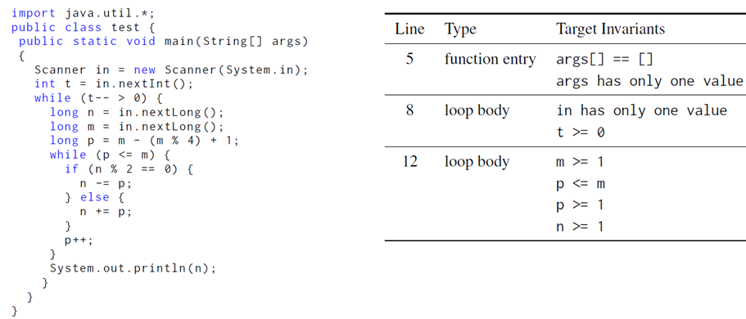
Figure 1: Sample LLM program and invariants.
The invariants obtained by the Daikon tool are, however, obtained by dynamic analysis. That is, they are found by executing a program with selected inputs. Since these inputs cannot cover all possible values, there are false positives with the invariants produced by the tool. The researchers in [5] had to refine this process to reduce the false positive rate by converting the programs and their generated invariants into a format suitable for model fine-tuning. They obtained 86% precision and 86% recall on a dataset of Java program. This prediction of correct invariants exceeds that of the Daikon dynamic analyzer.
Seizing on this promising result, the researchers in [6] aimed to construct an automated prover to verify the invariants put out by [5]. This framework was named LEMUR. Since these invariants may still be incorrect, this automated proving process requires revision of the incorrect invariant. In [6], this revision process is called repair. Hence, the automated prover, which interacts with LLM and was designed and built in [6], comprises the three main phases:
proposing, repairing, proving or making decisions. In the case when the verification phase leads to a false result, the proposed system has an ability to backtrack and correct the assumptions made before entering the proving phase.
The end-to-end process can be described by the following diagram in Figure 2 [6]:
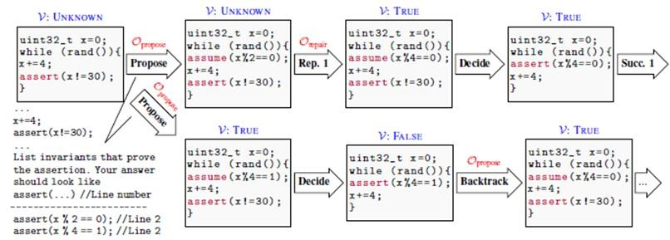
Figure 2: Combining LLMs and program refinement [6].
In this diagram, one can see how different phases – propose, repair, decide, backtrack – of LEMUR work in a sequential order. As a proof system, LEMUR was built from a set of deductive rules that seamlessly integrate different phases of formal proofs. Below are those deductive rules:
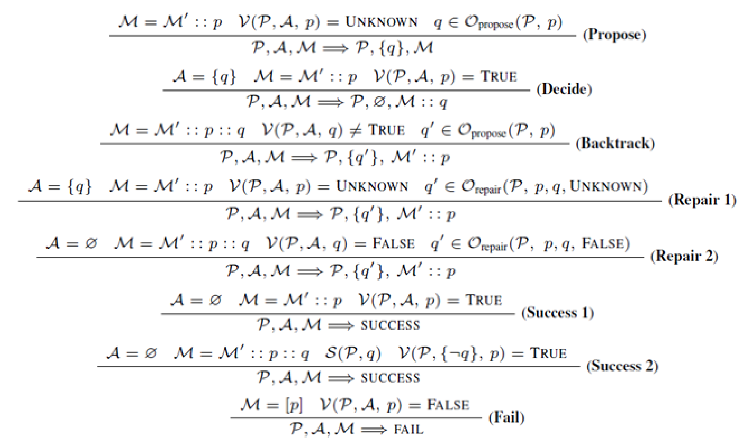
Note that these rules do not account for the logical formalism involved in the verification phase. That is, the rules are designed mainly for linking the four phases in a logically sound manner. In fact, the researchers showed that the LEMUR calculus based on these rules is sound. That is, starting with a program and an associated presumable invariant, if the automated proof process stops with success, then this presumed invariant can be repaired to true invariant and the program must satisfy the revised true invariant. Otherwise, if the proof process fails, then the revised invariant is not a program invariant.
The researchers built a prototype to illustrate the implementation of LEMUR. They also compared their results with the state-of-the-art result obtained in [7], which used deep learning by interacting with a proof checker. They found that their LEMUR proof system can solve 107 problems versus only 68 problems that could be solved with the methods in [7].
Despite promising success, LEMUR still faces many challenges. For example, dealing with more complex programs that contain multiple and/or nested loops remains an unsolved problem. In addition, since LLMs have token limits, many real programs require the number of tokens that exceed these limits.
Nonetheless, [5] and [6] are preliminary results that give us hope to integrate the machine learning capability of generative AI with the reasoning capability of formal systems. Together, these two frameworks can reinforce one another as shown in the design and implementation of
LEMUR.

Formal Methods Guided Iterative Prompting
Another method for enforcing that LLMs provide verifiably correct outputs is formal methods guided iterative prompting [9]. This technique is meant to be used in autonomous systems so that an LLM can work with a formal verification system through back-and-forth responses to arrive at a better solution than simply prompting the LLM once would. The first step in formal methods guided iterative prompting is providing the prompt to the LLM which specifies a problem. For example, the paper gives a simple example of a block-stacking problem where the data structures and allowed operations are specified. The LLM's initial response is provided to a formal verification system. The formal verification system is responsible for determining whether the LLM's solution is a valid solution or not. If it is valid, then the system can pass the solution out; however, if it is invalid, then the formal verifier should provide a counterexample, append this counterexample to the prompt, and give this new prompt to the LLM to repeat the cycle (Figure 3). Through this cycle, the LLM sees more constraints, and ideally should converge on a valid, verified solution. If the formal verification system has a mechanism for expressing why the LLM's solution is wrong, it should also provide that with the counterexample.
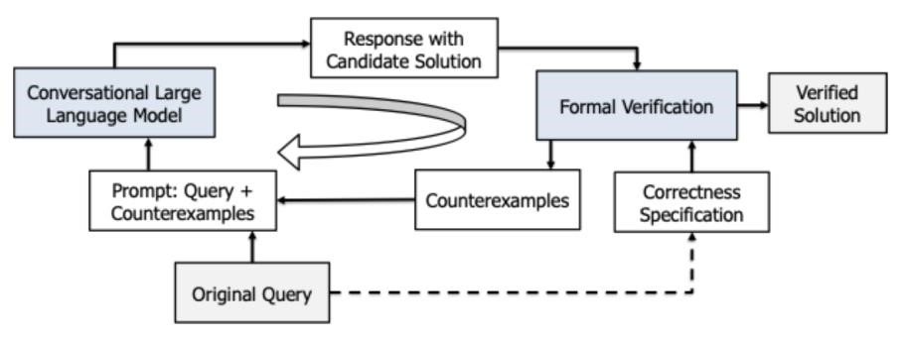
Figure 3: Combining LLMs and program refinement [9].
Notably, this approach has no dependence on the LLM itself, so even in the absence of a formal specification of the LLM it is possible to use this formal approach to improve the LLM's prediction quality in quite a lightweight manner. It is also agnostic to the choice of formal verification system; LLMs can typically be prompted to provide their responses in a format acceptable to a given formal verification system, and even if not, it is not hard to imagine a
rudimentary natural language processing system that can clean up the input.
Unfortunately, this paper does not discuss failures - it may be possible that the LLM simply lacks the knowledge to complete the problem, and no guarantee is provided that this iterative system is capable of converging to solutions to all problems. Nonetheless, the added rigor may help automate the process of prompt engineering and reduce the hallucination of large language models in some cases.

Large Language Model Fusion
The paper “The Fusion of Large Language Models and Formal Methods for Trustworthy
AI Agents: A Roadmap” [10] presents a summary of pathways to obtaining LLMs viable for real world applications. While the paper does not directly discuss prompt engineering, it does present methods that could be applicable during the training process for obtaining reliable outputs. Specifically, the paper discusses the organizational requirements for use and coupling opportunities with different formal methods to ensure LLMs have a reliable and flexible reasoning that is provably correct for a given application. Using the outlined guidance, an LLM’s qualities of adaptability, natural language processing, and knowledge base can be combined with the rigor, reasoning ability, and provable correctness of formal methods to build trust.
The biggest hurdle for current LLMs to inspire confidence is inconsistent language processing or wrong outputs (hence the relationship with prompt engineering). The authors suggest that the first step to overcoming these challenges happens at the user- or organizationallevel where the LLM is employed. To address this, the following requirements should be in place prior to having LLMs in place. First, the LLM agent should be implemented (or trained) inhouse, at the organization, so that regular use enables understanding of their workflow and domain-specific expertise. The next step is to develop a certification process involving testing, verification, validation, and adherence to operational or regulatory requirements that every output by an LLM goes through [10]. These administrative oversights for LLMs are crucial to obtaining the trust and legal compliance for critical applications.
For applications requiring increased reliability or certification-level confidence, Zhang et al. identify and demonstrate three methods to utilize formal methods with LLMs. The first method investigates the application of Satisfiability Modulo Theories (SMT) like Z3 [11] with LLMs. For this application the authors propose three strategies for integrating SMT solvers: 1) enabling multiple LLMs to debate, 2) having the LLM generate SMT code to check the consistency between the natural language description and the SMT code, and 3) implementing a feedback loop that iteratively converges SMT code to a known-correct solution. We could understand this third strategy as a concrete example of the general approach described in [9].
Second, is the use of LLMs that can perform formal methods tasks for theorem proving and model checking. It is well understood that barriers such as complexity, scalability, and manual inputs have limited wide-scale use of formal methods. Therefore, an LLM capable of auto-formalization would be incredibly beneficial for scalable and efficient verification. The authors demonstrate potential for this using Coq [12] and iterative model generation and checking using an Automated Prompt Engineer [13].
The final method proposed for integrating formal methods and LLMs is through formal program refinement for LLM behavior analysis, an especially important concept for managing hallucination. To confidently train an LLM to perform this function, key laws are set within a program's specification and used as checkpoints in code generation, verifying the execution trace comparison with predefined properties and backtracking if the verification fails [10]. This process is outlined below in Figure 4.
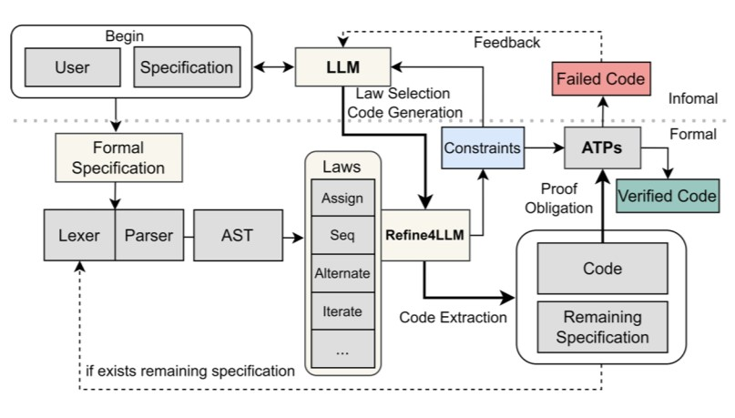
Figure 4: Combining LLMs and program refinement [10].
Empirical research into ChatGPT showed that half of the answers relating to programming questions contained errors; some of the research presented seeks to increase the ability of LLMs to translate natural language questions or requirements into better specifications or code than the error-prone outputs now [10]. To address this problem Zhang et al.
demonstrated multiple applications of formal methods to create trustworthiness and confidence in an LLM for real world applications. Abstracting these concepts, the frameworks and methods can also be applied in prompt engineering for any commercial LLM; enabling more robust, trustworthy, and provable LLMs.

Autoformalization with Large Language Models
An intriguing direction for applying formal methods to LLMs is explored in the work of Wu et al. titled “Autoformalization with Large Language Models” [14]. This research discusses how LLMs such as Codex and PaLM can automatically translate natural language mathematical statements into formal specifications in proof assistants like Isabelle/HOL. They were able to have resulting formal specifications become subject to machine checking by utilizing an LLM to produce full definitions, lemmas, and theorems. Once the LLM conversion of math competition problems are expressed as formal theorems, automated proof systems can verify the correctness of each logical step making sure mistakes would be caught systematically.
Even though Autoformalization can help add the ability with generating mathematical proof, it also can help with a framework to improve LLM’s reliability in a bigger scope. For instance, in prompt engineering workflows natural language could be cast into a formal language or adjusted with constraints which proof assistants can make sure are adjusted properly. Similar to translating math problems into Isabelle/HOL, it could conceive domain specific formal
“specification languages” that capture business rules, regulatory constraints, or even safety properties. The LLM content that is generated would then be checked against these specifications to automatically flag inconsistencies or errors. Thus, even a partial success rate, such as the 25%
“perfect” translation accuracy found in [14], has the potential to accelerate large scale production of candidate solutions that are verifiable by existing theorem proving frameworks.
The autoformalization approach joins well with the iterative correction loops mentioned in Sections 3.2 and 3.3. If an LLM can be prompted to produce a formally checkable specification, then this would be helpful to have a feedback mechanism that could show logical gaps or contradictions. The prompt would then reintroduce its counterexamples or proofs of failure into itself to improve its accuracy for the next round of solutions that would be generated. This process might yield better results in settings such as repeated prompting for the block stacking or program refinement cases.
Autoformalization is promising, but it still remains a challenge. With LLMs interpreting and then translating free form text into formal logic, it requires precise work and the current proof checker might not be able to cover all of the fields. As LLMs continue to improve their capabilities, the autoformalization pipelines can still help reduce the ambiguity with natural language to make it a more reliable machine checking layer. In doing so, it offers a clear plan to improve LLMs to be more reliable and trustworthy in other areas where accuracy is important.

Conclusion
Generative AI is a versatile tool for generating code, program invariants, and statements of mathematical lemmas or theorems. In all these instances, due to the inherent hallucination of generative AI, the generated texts may contain incorrect syntax or semantics. By leveraging formal methods, which are deductive, logical frameworks, syntax and semantic errors in the generated texts or code can be reduced. Conversely, the deductive techniques can guide prompt generation through an iterative process that would potentially generate more meaningful and accurate tokens. The four use cases discussed in this paper are samples of these interactive capabilities between generative AI and formal systems. As LLMs and formal methods are improved, a tighter coupling between learning (generative AI) and reasoning (formal methods) is expected. In the meantime, the interaction between the two systems may still require human expertise to resolve discrepancies between them.

References

- Liu, Y., Yao, Y., Ton, J. F., Zhang, X., Guo, R., Cheng, H., ... & Li, H. (2023). Trustworthy llms: a survey and guideline for evaluating large language models' alignment. arXiv preprint arXiv:2308.05374.

- Zhao, W. X., Zhou, K., Li, J., Tang, T., Wang, X., Hou, Y., ... & Wen, J. R. (2023). A survey of large language models. arXiv.org. preprint arXiv:2303.18223, 1(2). Available:
https://arxiv.org/abs/2303.18223

- Sahoo, P., Singh, A. K., Saha, S., Jain, V., Mondal, S., & Chadha, A. (2024). A systematic survey of prompt engineering in large language models: Techniques and applications. arXiv preprint arXiv:2402.07927.

- Cai, C., Zhao, X., Liu, H., Jiang, Z., Zhang, T., Wu, Z., ... & Li, L. (2024). The role of deductive and inductive reasoning in large language models. arXiv.org. Preprint arXiv:2410.02892.
- Pei, K., Bieber, D., Shi, K., Sutton, C., & Yin, P. (2024). Can large language models reason about program invariants? ICML'23: Proceedings of the 40th International Conference on Machine Learning, Article No. 1144, pp. 27496 - 27520.
- Wu, H., Barrett, C., & Narodytska N. (2024). Lemur: integrating large language models in automated program verification. International Conference on Learning Representations (ICLR'24). Available: https://arxiv.org/abs/2310.04870
- Xujie Si, Aaditya Naik, Hanjun Dai, Mayur Naik, and Le Song. Code2inv: a deep learning framework for program verification. In Shuvendu K. Lahiri and ChaoWang (eds.), Computer Aided Verification - 32nd International Conference, CAV 2020, Los Angeles, CA, USA, July 2124, 2020, Proceedings, Part II, Lecture Notes in Computer Science, Vol. 12225, pp. 151–164. Springer, 2020. https://doi.org/10.1007/978-3-030-53291-8_9.
- UW Program Languages and Software Engineering Group. The daikon invariant detector. Accessed: 4/6/25. Available: https://plse.cs.washington.edu/daikon/.
- Jha, S., Jha, S. K., Lincoln, P., Bastian, N. D., Velasquez, A., & Neema, S. (2023, June). Dehallucinating large language models using formal methods guided iterative prompting. In 2023 IEEE International Conference on Assured Autonomy (ICAA) (pp. 149-152). IEEE.

- Zhang, Y., Cai, Y., Zuo, X., et al. (2024). The fusion of large language models and formal methods for trustworthy ai agents: A roadmap. arXiv.org. Accessed: 3/23/25. Available:
https://arxiv.org/abs/2412.06512.

- De Moura, L., & Bjørner, N. (2008). Z3: an efficient smt solver. In “Tools and Algorithms for the Construction and Analysis of Systems,” C. R. Ramakrishnan and Jakob Rehof (Eds.).
Springer Berlin Heidelberg, Berlin, Heidelberg, pp. 337–340.

- Huet, G., Kahn, G., & Paulin-Mohring, C. (1997). The coq proof assistant a tutorial. Rapport Technique, 178, 113.

- Cheng, J., Liu, X., Zheng, K., Ke, P., et al. (2023). Black-box prompt optimization: Aligning large language models without model training. arXiv.org. Accessed: 4/2/25. Available: https://arxiv.org/abs/2311.04155.

- Wu, Y., Jiang, A. Q., Li, W., Rabe, M. N., Staats, C., Jamnik, M., & Szegedy, C. (2022). Autoformalization with large language models. arXiv:2205.12615.

